**Navigation between the Views**

**By the end of this tutorial you will be able to know**

* Creating a new view in SAP UI5
* Defining the view in index file
* Navigating from one view to other view

1. **Create a New View using the below path**

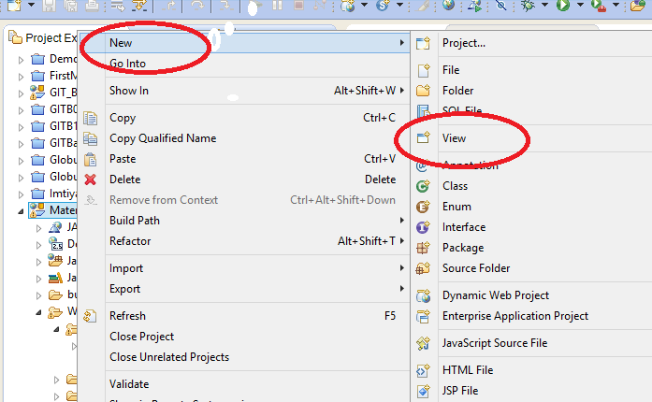

1. **Enter the name of the view as "second" and select xml as the view type as below and click on Next button below**

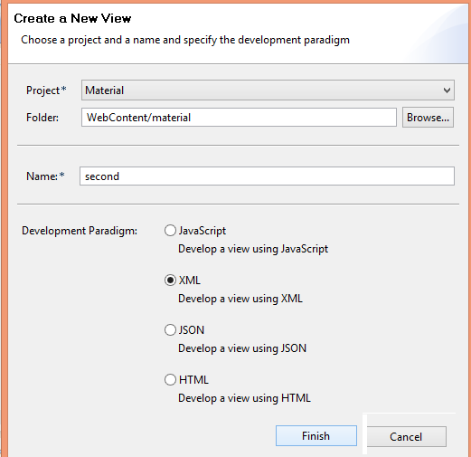

1. **Open Index.html and add the below two highlighted lines of code**

sap.ui.localResources("material");

**var** app = **new** sap.m.App({initialPage:"idwelcome1"});

**var** page = sap.ui.view({id:"idwelcome1", viewName:"material.welcome", type:sap.ui.core.mvc.ViewType.XML});

**var** page2 = sap.ui.view({id:"idsecond1", viewName:"material.second", type:sap.ui.core.mvc.ViewType.XML});

app.addPage(page);

app.addPage(page2);

app.placeAt("content");

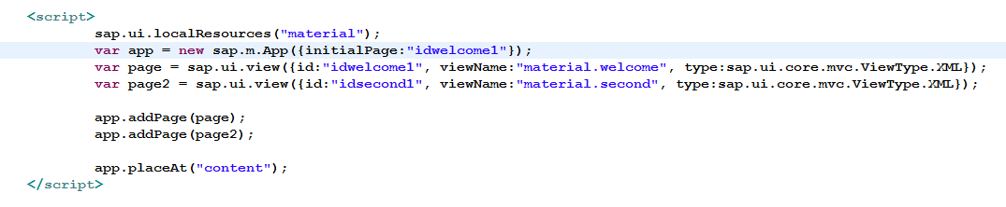

1. **Open the First View and past the Below Code inside Content tag**

<content>

<Label id=*"idlblname"* design=*"Bold"* required=*"false"* text=*"Enter your First Name"*></Label>

<Input id=*"idname"* type=*"Text"* width=*"300px"* ></Input>

<Button id=*"idbtn"* text=*"GotoSecond"* type=*"Accept"* width=*"200px"* press=*"onClick"*></Button>

</content>

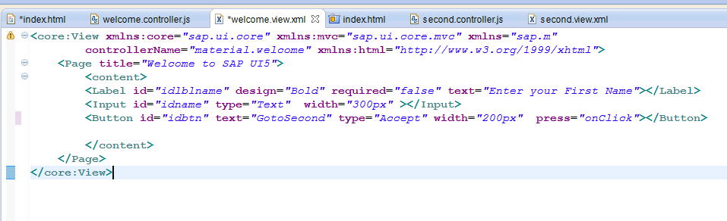

1. **Open the second view and change the title as below**

<Page title=*"Welcome to the Second view "*>

1. **Open the First View controller and paste the below line of code inside**

onClick: **function**()

{

app.to("idsecond1");

}

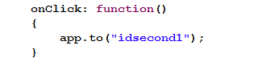

save all and refresh the browser and see the output. You will be able to navigate from first view to second

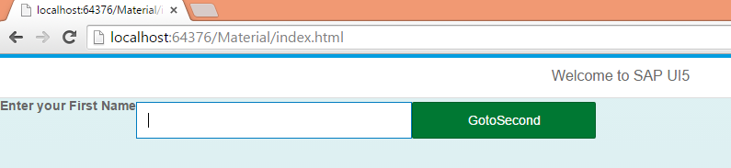

click on the button

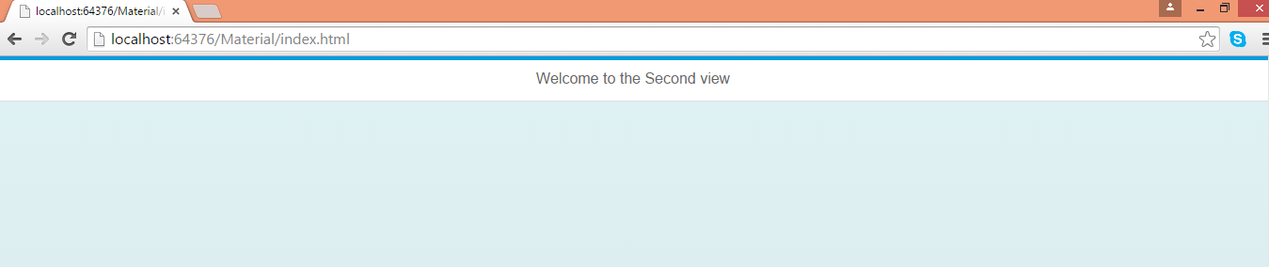

you are on the second page .

1. **changin the navigation style using "flip"**

Open the Controller code in welcome view and add one more parameter "flip" as below.

onClick: **function**()

{

app.to("idsecond1","flip");

}

save all and refresh the browser. You see the flip style of navigation to the second page.

Similarly you create back button in the second page and navigate to the first page.

1. **Creating a Back navigation in the Header part of second view.**

Open the second view and add this properties in the Page tag as below

<Page title=*"Welcome to the Second view"* showNavButton=*"true"* navButtonTap=*"onBack"*>

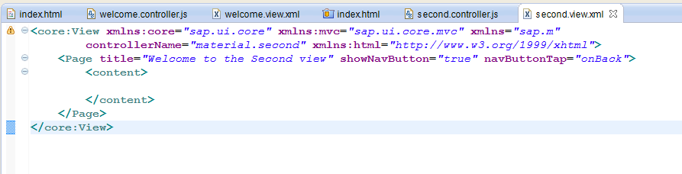

Now Open the Controller and implement the event handler for the back Navigation: **onBack**

onBack: **function**()

{

app.to("idwelcome1");

}

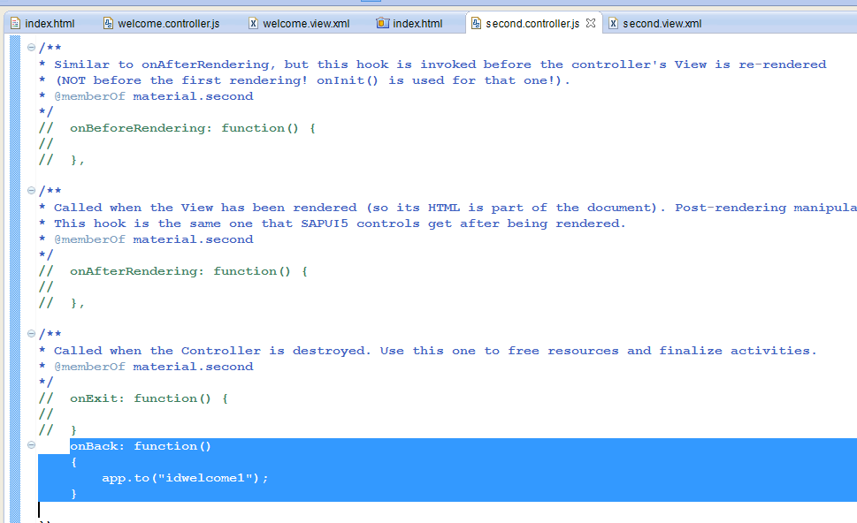

save all and refresh the browser. You will get a back navigation button and once you click on that you will land up in welcome page

output1:click on the button

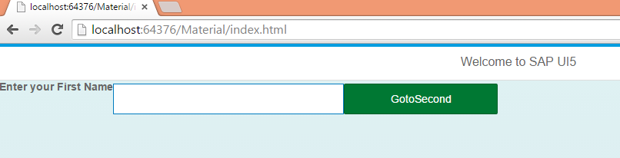

output2: click on the back navigation button

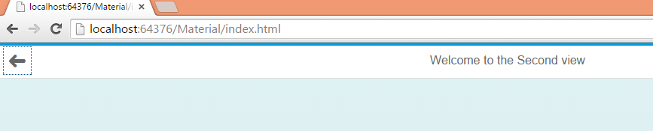

output3:u will land up in welcome view

